**S. SWETHA** 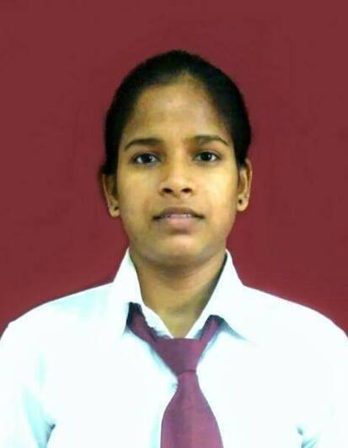

*Plot-130, Shrungeri Colony,*

*Mohan Nagar, Kothapet, Hyderabad-5600*

C:\Users\sravanthi.sankendla\Desktop\Capture.PNG (+91) 8171407596 |  [s.shweta.minz@gmail.com](mailto:s.shweta.minz@gmail.com)

### Career Objective

##### To work in a challenging, dynamic and professional environment where I can explore my technical and interpersonal skills to the optimum and deliver the best to contribute towards achieving the organization goals.

##### Academic Qualification

|  |  |  |  |  |
| --- | --- | --- | --- | --- |
| Examination | School/  College | Board/  University | Year of  Passing | Class% /  CGPA |
| B. TECH  (COMPUTER  SCIENCE) | ICFAI, Dehradun | ICFAI University | 2017 | 7.72  (6th semester) |
| Higher  Secondary - (PCM) | Pragati Vidhya Peeth,  Gwalior | CBSE | 2013 | 6.4 |
| SSLC | Army Public School,  Gwalior | CBSE | 2011 | 8.4 |

##### Personality Traits

* Determined, go getter approach.
* Self- motivated and eager to learn new things
* Flexibility and adaptable
* Effective communication and interpersonal skills
* Ability to work as individual as well as in team

**Software Exposure**

* Web technologies: HTML, CSS
* Database: SQL SERVER ,ORACLE 10g
* Development Tools: Visual Studio
* Languages:  C, JAVA, C#

**Academic Project**

###### Summer internship

Company: HP EDUCATION, Hyderabad

Duration: 2 months

Project title: Online Examination System

Environment: Visual Studio 2013

Database: MS SQL SERVER 2008

Language: ASP.NET WITH C#, HTML, CSS

**Description**: Online Examination System is a web based application for technical

evaluation. Sitting at one location the test conductor can take quiz of 100 student sitting at

different locations in front of computers. It is multiple choice questions based examination

system. Response by the candidates will be checked automatically and instantly. The result

will be shown immediately to the participating students reducing the anxiety. The test

conductor can change the questions timely.

* **Academic project**

Duration: 15 days

Project title: Examination system

Environment: Visual studio 2013

Database: MS SQL SERVER 2008

Language: C#

**Description:** examination system is software used for technical evaluation. It is offline quiz

conductor which can be used in schools and colleges to reduce the hectic job of assessing

the answers given by candidates manually. It reduces paper work.

* **Academic project**

Duration: 4 months

Project title: student grading system

Environment: Visual studio 2013

Database: ms excel

Language:c#

##### Achievements

* Secured second place for t-shirt painting at college level
* Secured first place in Rangoli competition at school and college level
* Secured third position in interschool painting competition.
* Represented my house as house captain in school.
* Bagged prizes in marathon, dance competition, poem recitation

**Workshops and Trainings**

* Attended the Summer Training Program conducted by HPES at Hyderabad from 19th May 2015 to 2nd July 2015 on Asp.net with C#
* Attended workshops conducted by Orien IT (Hyderabad) on “BIG DATA HADOOP”

**Personal Profile**

Date of Birth: 01-10-1994

Father’s Name: Mr. S. KHAJA

Nationality: Indian

Community: Hindu

Gender: Female

Marital Status: Single

Language known: English, Hindi, Telugu

**Declaration:** I hereby declare that all the details furnished above are true to the best of my knowledge and belief.